MMK101 Marketing Fundamentals

Segmentation, Targeting, Differentiation and Positioning Strategy
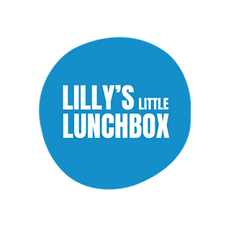
https://www.lillyslittlelunchbox.com/

Trimester 2, 2025

Student Name: Minh Nguyen Khac Ha
Student Number: 225443664
Assignment Word Count: 749

Please use the checkboxes to indicate all the different ways you used AI in completing this assignment.
Generative AI Uses
- Clarification of marketing concepts | X
- Creative/visuals
- Drafting/writing  - Which sections: 1.2, 4.1 | X
- Editing / re-wording | X
- Reference formatting | X
- Other
  - Describe:
No AI usage.
(Only click this if you do not click any of the other boxes.)
- Referencing Generative Artificial Intelligence (AI) tools (eg. ChatGPT): e.g., as generated by the generative AI program (OpenAI, 2023); According to OpenAI (2023) ChatGPT states that the relationship between ... and ...
- Reference list: OpenAI. (2023). ChatGTP (Mar 14 version) [Large language model]. https:chat.openai.com/chat
In MMK101 Marketing Fundamentals, we use a live case study which addresses a real industry/company problem or opportunity. We will provide the focal company with the top five (5) reports as judged by the MMK101 Marketing Fundamentals Unit Team.
If your assignment is chosen to be provided to the focal organisation, do you give permission?
Yes No X

Table of Contents
1. Background 4
1.1. Company Overview 4
1.2. Industry Analysis 4
2. Consumer Market Segmentation 8
3. Target Market and Consumer Profile 9
3.1. Target Market 9
3.2. Consumer Profile/Persona 10
4. Differentiation and Positioning Strategy 11
4.1. Differentiation Strategy 11
4.2. Positioning Statement 11
4.3. Positioning Map 12
Reference List 13

1. Background

1.1. Company Overview
Lily’s Little Lunchbox is a meal delivery company founded by dietitian Cara Aprile. The business specializes in providing fresh, ready to eat meals. Their products focus on the 5 core food groups (Aprile & Heydon, 2025), and on providing customer convenient experiences. The meals are tailored for kids but also serve parents, seniors and individuals living with disability. Lily’s mission is to promote healthy eating habits.

1.2. Industry Analysis
The Australian fresh and easy lunch witnessed a steady growth, driven by demand for convenient nutritious meals. According to Manson et al. (2021the diets of school aged children are unhealthy, containing high levels of fat and sugar but low in essential nutrients. Flexischools (2025) also found that Australian parents spend an estimated 135.2 hours and AUD $3,120 each year preparing school lunches, an exorbitant amount for families struggling to pay for these common necessities. Lily’s Little Lunchbox are therefore well positioned with the emerging trends, which are suitable for time poor parents who struggle to prepare nutritious meals for their children.
Figure 1: Sales of Ready Meals in Australia (2010-2029)
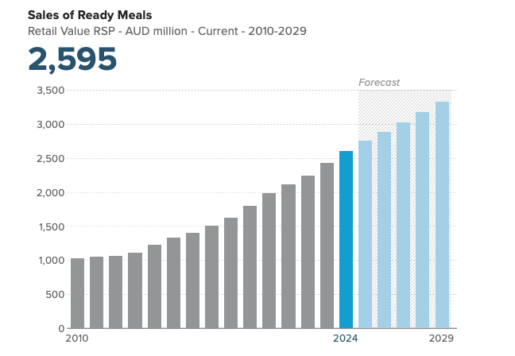

Source: Euromonitor International, 2024
Figure 1 shows the market increasing in sales significantly from just over AUD 1 billion in 2010, and then more than doubling to approximately AUD 2.6 billion in 2024. Furthermore, this following trend highlights that this may be driven from a rising customer interest in convenient meal plans and the conscious dietary preference for more healthy and nutritious food. This graph forecasts that sales may grow to an estimated 3.3 billion by 2029, which may show that Lily’s Little Lunchbox are likely to grow in sales.

Micro environmental
Lily’s Little Lunchbox compete with other food service providers. Major players like HelloFresh target adults and require cooking skills, which make them less suitable for busy families with children. While other option for lunch, like school canteen or meal kit companies often fail to meet up the nutritious standards. By offering ready to eat, dietitian approved and lunchbox tailored meals to children, Cara Aprile’s company will stand out as a healthier and more convenient option for busy families.
Macro environmental
Figure 2: Consumer Price Index, Australia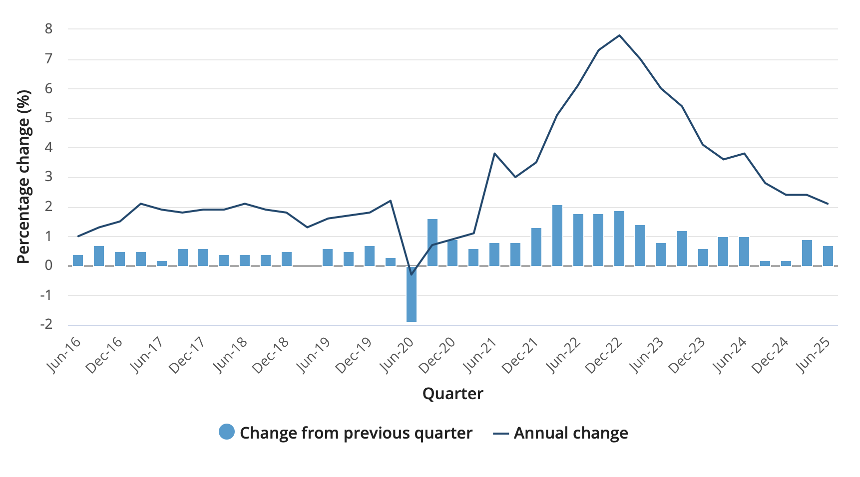
Source: Australian Bureau of Statistics, 2025
Figure 2 demonstrates a downward trend since June 2024, indicating a fall in overall prices for goods and services, including a decline in the cost of food and groceries. Cara Aprile’s company can still leverage this economic trend by positioning their lunchbox as an affordable and time saving product, in the case of cautious spending habits and future economic volatility.

Figure 3: Sales of Digital Shopper (E-Commerce Goods and Services) by Category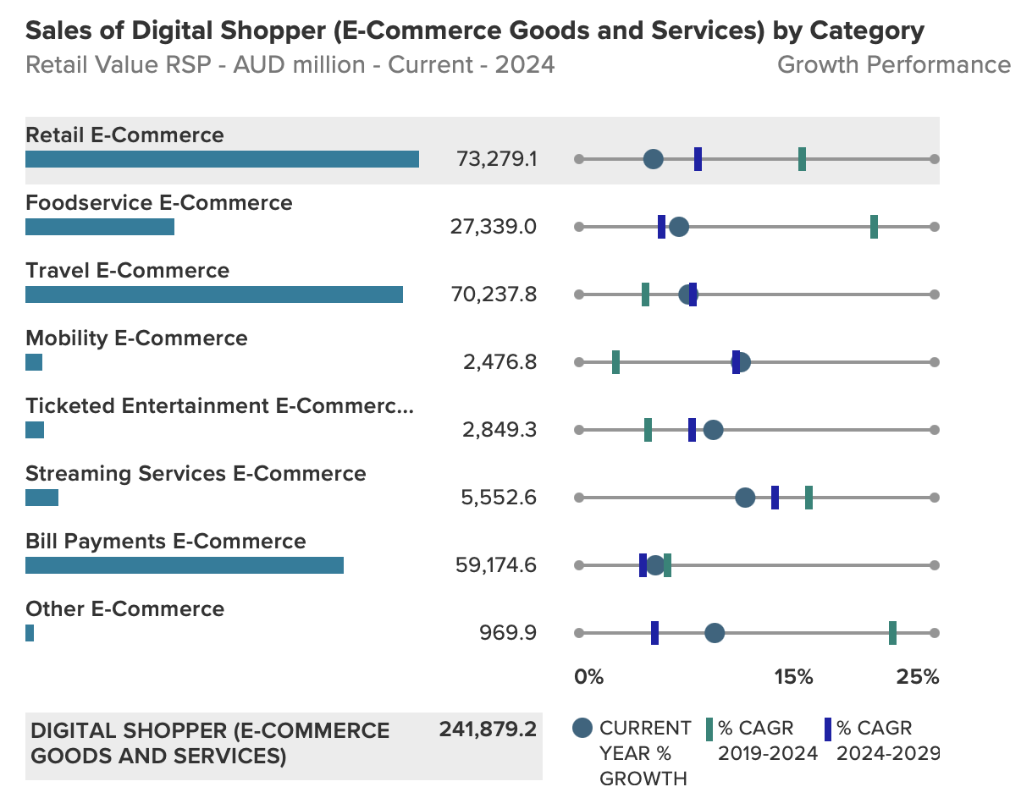
Source: Euromonitor International, 2025
Advancements in technology and the rise of online food ordering may have significantly transformed how families access meals. According to Figure 3, Foodservice E-Commerce generated AUD $27.3 billion in 2024, ranking third largest e-commerce categories. These advantages allow Lily’s Little lunchbox to deliver nutritious meals directly to customer avoiding third party platforms. By managing their own website and delivery system, this helps reduce the transactions costs and create a better customer experience.

2. Consumer Market Segmentation
2.1. Segmentation
Table 1: Consumer market segments
 | Working mums who buy food for the family | International student living alone | Single parents on a tight budget
Geographic
Region | South-Eastern Queensland | Western NSW | South-Eastern Queensland
Demographic
Age (years) | 25 to 45 | 18 to 25 | 25 to 45
Sex | Female | Female | Male
Psychographic
Value, attitudes and lifestyle | Conventional Family Life | Young Optimist | Basic Needs
Personality | Gregarious, ambitious | Ambitious | Ambitious, resilient
Behavioral
Attitude towards product | Enthusiastic | Positive | Positive
Benefits sought | Quality, service | Service | Service, affordability

3. Target Market and Consumer Profile

3.1. Target Market
The primary target for Lily’s Little Lunchbox is Working mums, typically aged 25 to 45 years old, living in urban areas in Queensland. Compared to students, working mothers are a more loyal segment suited to Lily’s subscription-based model. Australian mothers are the largest user group of food delivery websites and apps (Gibbs, 2024). In Queensland, 22.9% of couple families had both parents working full time representing over 255,000 households in 2021 (Australian Bureau of Statistics, 2021). With a tight schedule, working mums may find it challenging and stressful to plan and organize lunchbox for their children (Mehta et al, 2020). Lily’s Little Lunchbox provides an appropriate solution to this challenge.

3.2. Consumer Profile/Persona
Education
Bachelor’s degree in Journalism
Work/Study Experience
Director of Content Strategy

Background
Psychographic
Values: Health, family wellbing, quality
Aspirations: To raise healthy children while achiving a successful carrer
Anxieties/Challenges: Struggles to prepare nutrious lunches daily

`
Huong Nguyen


I’m a busy working mum who has wonderful kids
Buyer Behaviour
Purchase occasion: Regular, weekly ordering
Benefits sought: Quality, health, convenience
User status: Regular user
Usage rate: Heavy

Media Habits
Frequently uses Facebook for entertainment, and lunch ideas
Goals:

k
Key Characteristics
1. Gregarious

2. Ambitious

3. Practical

Hobbies and Interests
Play musical instrument, Travel
Favourite brands
Uniqlo, Woolworths
Influences
Social media, reviews from others

Personal Preferences
Figure 1: Consumer Profile/Persona
Age: 43
Gender: Female
Marital status: Married
Income: $90,000-$100,000 / year
Location: Brisbane, Queensland, Australia

Demographics

4. Differentiation and Positioning Strategy

4.1. Differentiation Strategy
Firstly, Lily’s Little Lunchbox provides dietitian designed, nutritious, and high-quality fresh meals. Unlike canteen food, these lunchboxes are made from the five core groups and remain fresh in the fridge for a week due to their special packaging (Aprile & Heydon, 2025), making them much more convenient for customer.
Families only need to place their order once per week, helping mothers save time and avoid daily meal preparation. This convenience reduces daily stress and saving time for parents.

4.2. Positioning Statement
To busy working mothers, who struggle to prepare lunchbox for their families, Lily’s Little Lunchbox offers a convenient meal and delivery service that offers you a healthy eating habit designed by dietitian based on the five core food groups (Aprile & Heydon, 2025) and are delivered weekly to save time and reduce daily stress.

4.3. Positioning Map

Figure 2: Positioning Map
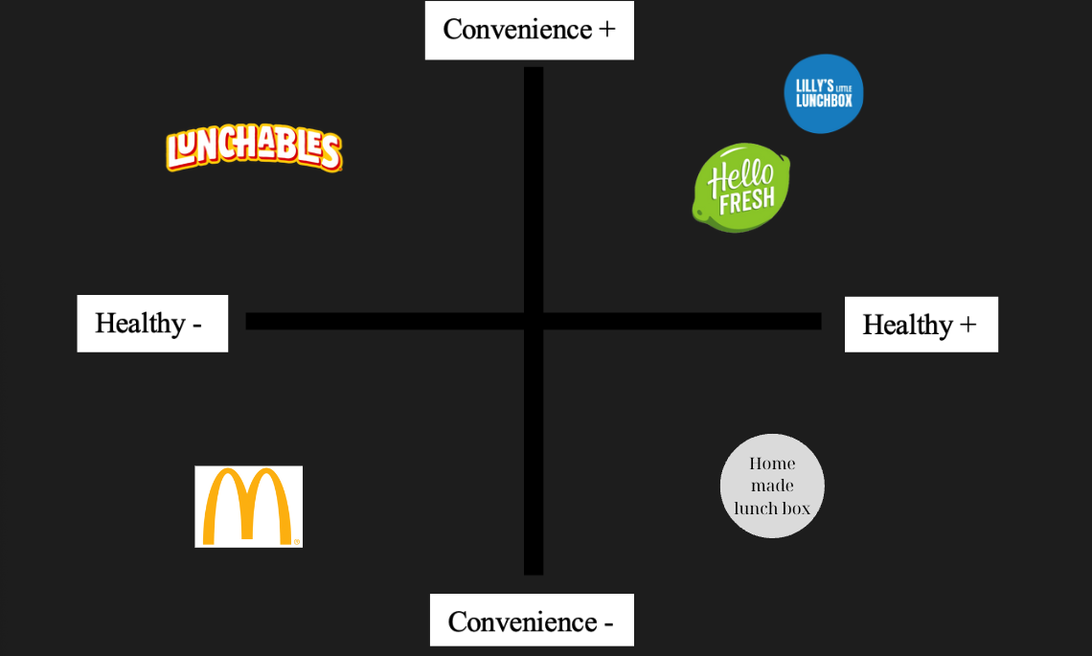

Reference List
Australian Bureau of Statistics. (2024, October 22). Labour force status of families. Australian Bureau of Statistics. https://www.abs.gov.au/statistics/labour/employment-and-unemployment/labour-force-status-families/latest-release
Australian Bureau of Statistics . (2025). Consumer Price Index, Australia, June Quarter 2025. Australian Bureau of Statistics. https://www.abs.gov.au/statistics/economy/price-indexes-and-inflation/consumer-price-index-australia/jun-quarter-2025
Australian Bureau of Statistics. (2021). 2021 Queensland, Census All persons QuickStats | Australian Bureau of Statistics. Abs.gov.au; Australian Bureau of Statistics. https://www.abs.gov.au/census/find-census-data/quickstats/2021/3?utm_source=chatgpt.com
Aprile, C., & Heydon, C. (2025, February 25). Interview about Lily’s Little Lunchbox (C. Dubelaar, interviewer) [Interview transcript]. In Deakin University Panopto. https://deakin.au.panopto.com/Panopto/Pages/Viewer.aspx?id=66712ae1-4922-4283-92e5-b28f0000740f
Euromonitor International. (2024, October). Ready meals in Australia. Passport. https://www.euromonitor.com
Euromonitor International. (2024). Sales of digital shopper (e-commerce goods and services) by category – Australia. Passport. https://www.euromonitor.com

Flexischools. (2025, February 21). Australian parents to spend more than 100 hours preparing school lunches in 2025. News for the Food Lover. https://newsforthefoodlover.com/?s=Australian+parents+to+spend+more+than+100+hours+preparing+school+lunches+in+2025
GIBBS, K. (2024, March 31). The massive problem with having our food delivered. Couriermail; The Courier Mail. https://www.couriermail.com.au/lifestyle/food/have-food-delivery-apps-become-too-expensive/news-story/d04cf11060cd2ce633d95a78c186dadd?utm_source=chatgpt.com
Lily’s Little Lunchbox. (n.d.). Home delivery. Retrieved August 2, 2025, from https://www.lillyslittlelunchbox.com/home-delivery
Manson, A. C., Johnson, B. J., Zarnowiecki, D., Sutherland, R., & Golley, R. K. (2021). The food and nutrient intake of 5- to 12-year-old Australian children during school hours: a secondary analysis of the 2011–2012 National Nutrition and Physical Activity Survey. Public Health Nutrition, 24(18), 1–10. https://doi.org/10.1017/s1368980021003888
Mehta, K., Booth, S., Coveney, J., & Strazdins, L. (2020). Feeding the Australian family: challenges for mothers, nutrition and equity. Health Promotion International, 35(4), 771–778. https://doi.org/10.1093/heapro/daz061
McDonald’s Corporation. (2019, October 23). Golden Arches logo [Logo]. https://corporate.mcdonalds.com/corpmcd/our-stories/media-assets-library/media-article/golden_arches_logo.html
1000 Logos. (n.d.). HelloFresh logo. 1000logos.net. Retrieved August 2, 2025, from https://1000logos.net/hellofresh-logo/
1000 Logos. (n.d.). Lunchables logo. 1000logos.net. Retrieved August 2, 2025, from https://1000logos.net/lunchables-logo/

